**Bayer Low Tunnel Volatility Study**

Summary of 20-ARL-SB21 study

*Rodrigo Werle1, Ryan DeWerff 2, Nick Arneson3, Sarah Striegel 4, Nikola Arsenijevic5, Felipe Faleco5, Kolby Grint5, Haleigh Ortmeier-Clarke5, Jose Nunes6 and Emily Glaeser 7*

*1 Principal Investigator, 2 Research Technician, 3 Outreach Research and Extension Associate, 4 Former Graduate Student, 5 Graduate Student, 6 Visiting Scholar,*

*7 Undergraduate Research Assistant*

Questions on the contents of this report should be directed to Rodrigo Werle (rwerle@wisc.edu) and Sarah Striegel ([sstriegel@wisc.edu](mailto:sstriegel@wisc.edu)).

**

**Contents**

Methods...................................................................................................................................... 5

Results......................................................................................................................................... 7

**List of Figures**

Figure 1. MON 301286 – RupXtend II VGrip at 28 DAT............................................... 12

Figure 2. MON 301286 – RupXtend II VGrip + Intact at 28 DAT............................... 13

Figure 3. MON 301286 – RupXtend II VGrip + Impetro II at 28 DAT...................... 14

Figure 4. MON 301286 – RupXtend II VGrip + MON 51817 – VaporGrip at 28

DAT.......................................................................................................................................... 15

Figure 5. MON 301286 – RupXtend II VGrip + MON 51817 – VaporGrip + Intact

at 28 DAT................................................................................................................................. 16

Figure 6. MON 301286 – RupXtend II VGrip + MON 51817 – VaporGrip +

Impetro II at 28 DAT............................................................................................................. 17

Figure 7. MON 301286 – RupXtend II VGrip + MON 301471 – VaporGrip + Guar

at 28 DAT................................................................................................................................. 18

Figure 8. MON 301286 – RupXtend II VGrip + MON 301916 – VaporGrip + PCA

at 28 DAT................................................................................................................................. 19

Figure 9. Nontreated Check at 28 DAT............................................................................... 20

**List of Tables**

Table 1. Weather conditions in the 48 h period of flat placement under the low tunnels at the University of Wisconsin-Madison Arlington Agriculture Research

Station........................................................................................................................................ 6

Table 2. Sum of soybean stand count, sum of injured plants and the % of injured soybean plants 14 and 28 days after treatment in the three replications within 25 ft quadrant at the University of Wisconsin-Madison Arlington Agriculture Research

Station....................................................................................................................................... 11

**Methods**

* Soybean variety: CZ 2550GTLL
* Soybean seeding rate: 140,000 seeds ac-1 at 1.5” depth
* Soybean row width: 30” row width
* Soybean planting date: June 1
* Plot maintenance:
* PRE herbicide treatment – June 1, 6 oz ac-1 Authority First (+ 26 fl oz ac-1 Roundup PowerMax to control emerged weeds)
* POST herbicide treatment – June 23, 22 fl oz ac-1 Roundup PowerMax + 8.5 lbs AMS/100 gal
* Herbicide treatment (flats): 8:00 to 9:05 am June 30
* Soybean stage at flat application: V4
* Flat removal from low-tunnel: 8 to 9:05 am July 1
* Results presented at 14 and 28 days after treatment (DAT) for the 25-ft quadrant with the most severe and consistent injury
* Photos taken at 28 DAT

Table 1. Weather conditions in the 48 h period of flat placement under the low tunnels at the University of Wisconsin-Madison Arlington Agriculture Research Station.

|  |  |  |  |  |  |  |  |  |  |  |  |  |  |  |  |  |
| --- | --- | --- | --- | --- | --- | --- | --- | --- | --- | --- | --- | --- | --- | --- | --- | --- |
| Date | Soil flat temp (F) | | | Air temp (6 in, F) | | | Air temp (27 in, F) | | | Relative humidity (%) | | | Air temp (39 in, F) | | | Rainfall (in) |
| Avg | Max | Min | Avg | Max | Min | Avg | Max | Min | Avg | Max | Min | Avg | Max | Min |
| 0-24 h | 80.0 | 93.1 | 66.1 | 79.9 | 93.3 | 64.8 | 79.3 | 91.6 | 65.3 | 79.9 | 93.5 | 59.7 | 77.0 | 88.2 | 65.3 | 0.0 |
| 24-48 h | 83.2 | 108.0 | 64.2 | 78.5 | 100.1 | 61.1 | 77.3 | 96.2 | 61.4 | 72.7 | 91.0 | 50.8 | 73.9 | 87.8 | 61.0 | 0.0 |

**Results**

 Source: University of Wisconsin-Madison Cropping Systems Weed Science, 2020



Source: University of Wisconsin-Madison Cropping Systems Weed Science, 2020



Source: University of Wisconsin-Madison Cropping Systems Weed Science, 2020

 Source: University of Wisconsin-Madison Cropping Systems Weed Science, 2020

Table 2. Sum of soybean stand count, sum of injured plants and the % of injured soybean plants 14 and 28 days after treatment in the three replications within 25 ft quadrant at the University of Wisconsin-Madison Arlington Agriculture Research Station.

|  |  |  |  |  |  |
| --- | --- | --- | --- | --- | --- |
| Treatment | Stand count | Injured plants | | %, Injured plants | |
| 14 | 28 | 14 | 28 |
| MON 301286 – RupXtend II VGrip | 177 | 115 | 118 | 64.6 | 66.7 |
| MON 301286 – RupXtend II VGrip + Intact | 176 | 99 | 106 | 55.9 | 60.0 |
| MON 301286 – RupXtend II VGrip + Impetro II | 172 | 106 | 93 | 61.6 | 53.6 |
| MON 301286 – RupXtend II VGrip + MON 51817 - VaporGrip | 174 | 82 | 76 | 47.3 | 43.7 |
| MON 301286 – RupXtend II VGrip + MON 51817 – VaporGrip + Intact | 179 | 77 | 70 | 42.4 | 39.2 |
| MON 301286 – RupXtend II VGrip + MON 51817 – VaporGrip + Impetro II | 175 | 56 | 78 | 32.4 | 44.7 |
| MON 301286 – RupXtend II VGrip + MON 301471 – VaporGrip + Guar | 171 | 89 | 75 | 52.2 | 43.9 |
| MON 301286 – RupXtend II VGrip + MON 301916 – VaporGrip + PCA | 175 | 103 | 89 | 59.1 | 50.9 |
| Nontreated Check | 179 | 0 | 0 | 0.0 | 0.0 |

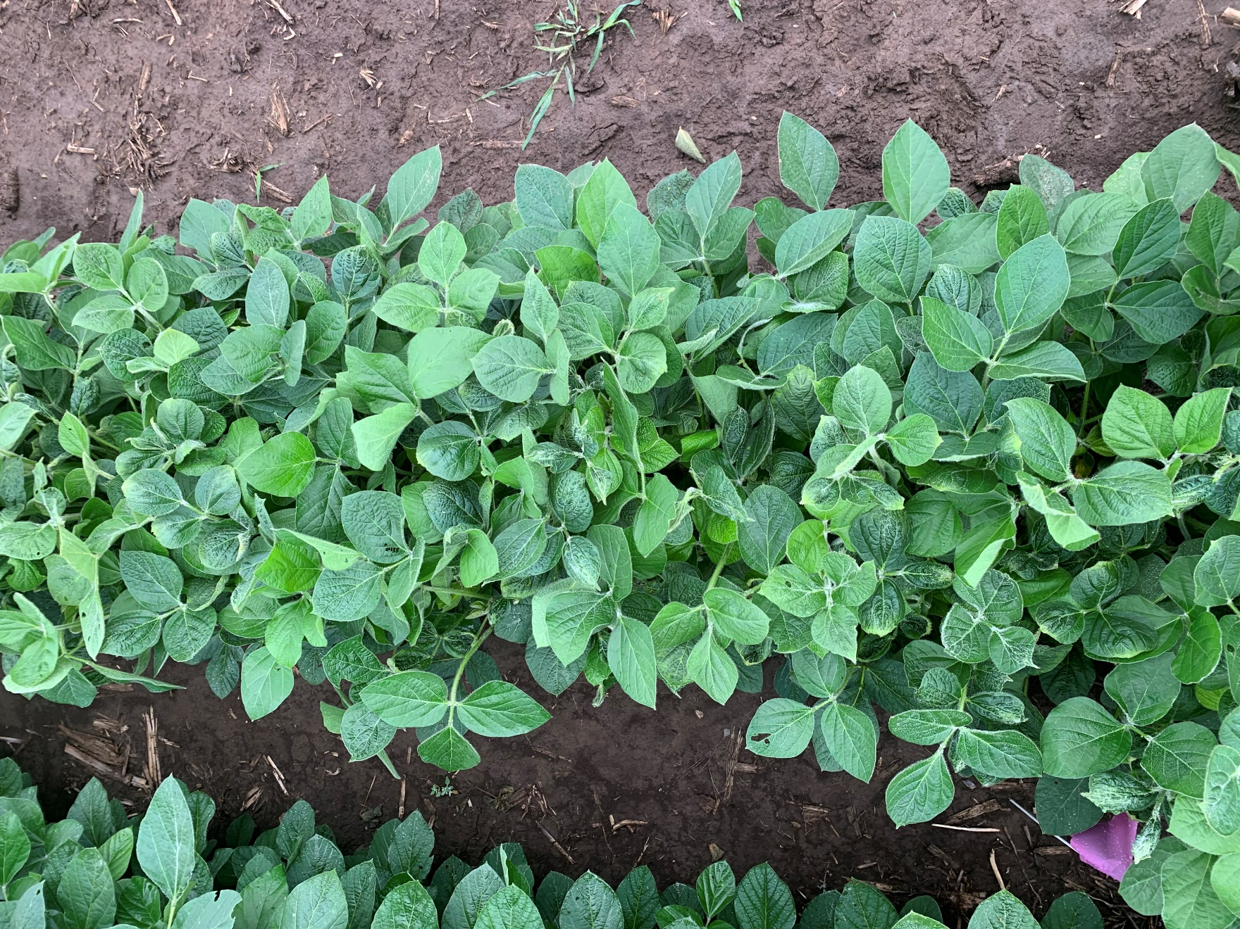

Figure 1. MON 301286 – RupXtend II VGrip at 28 DAT.

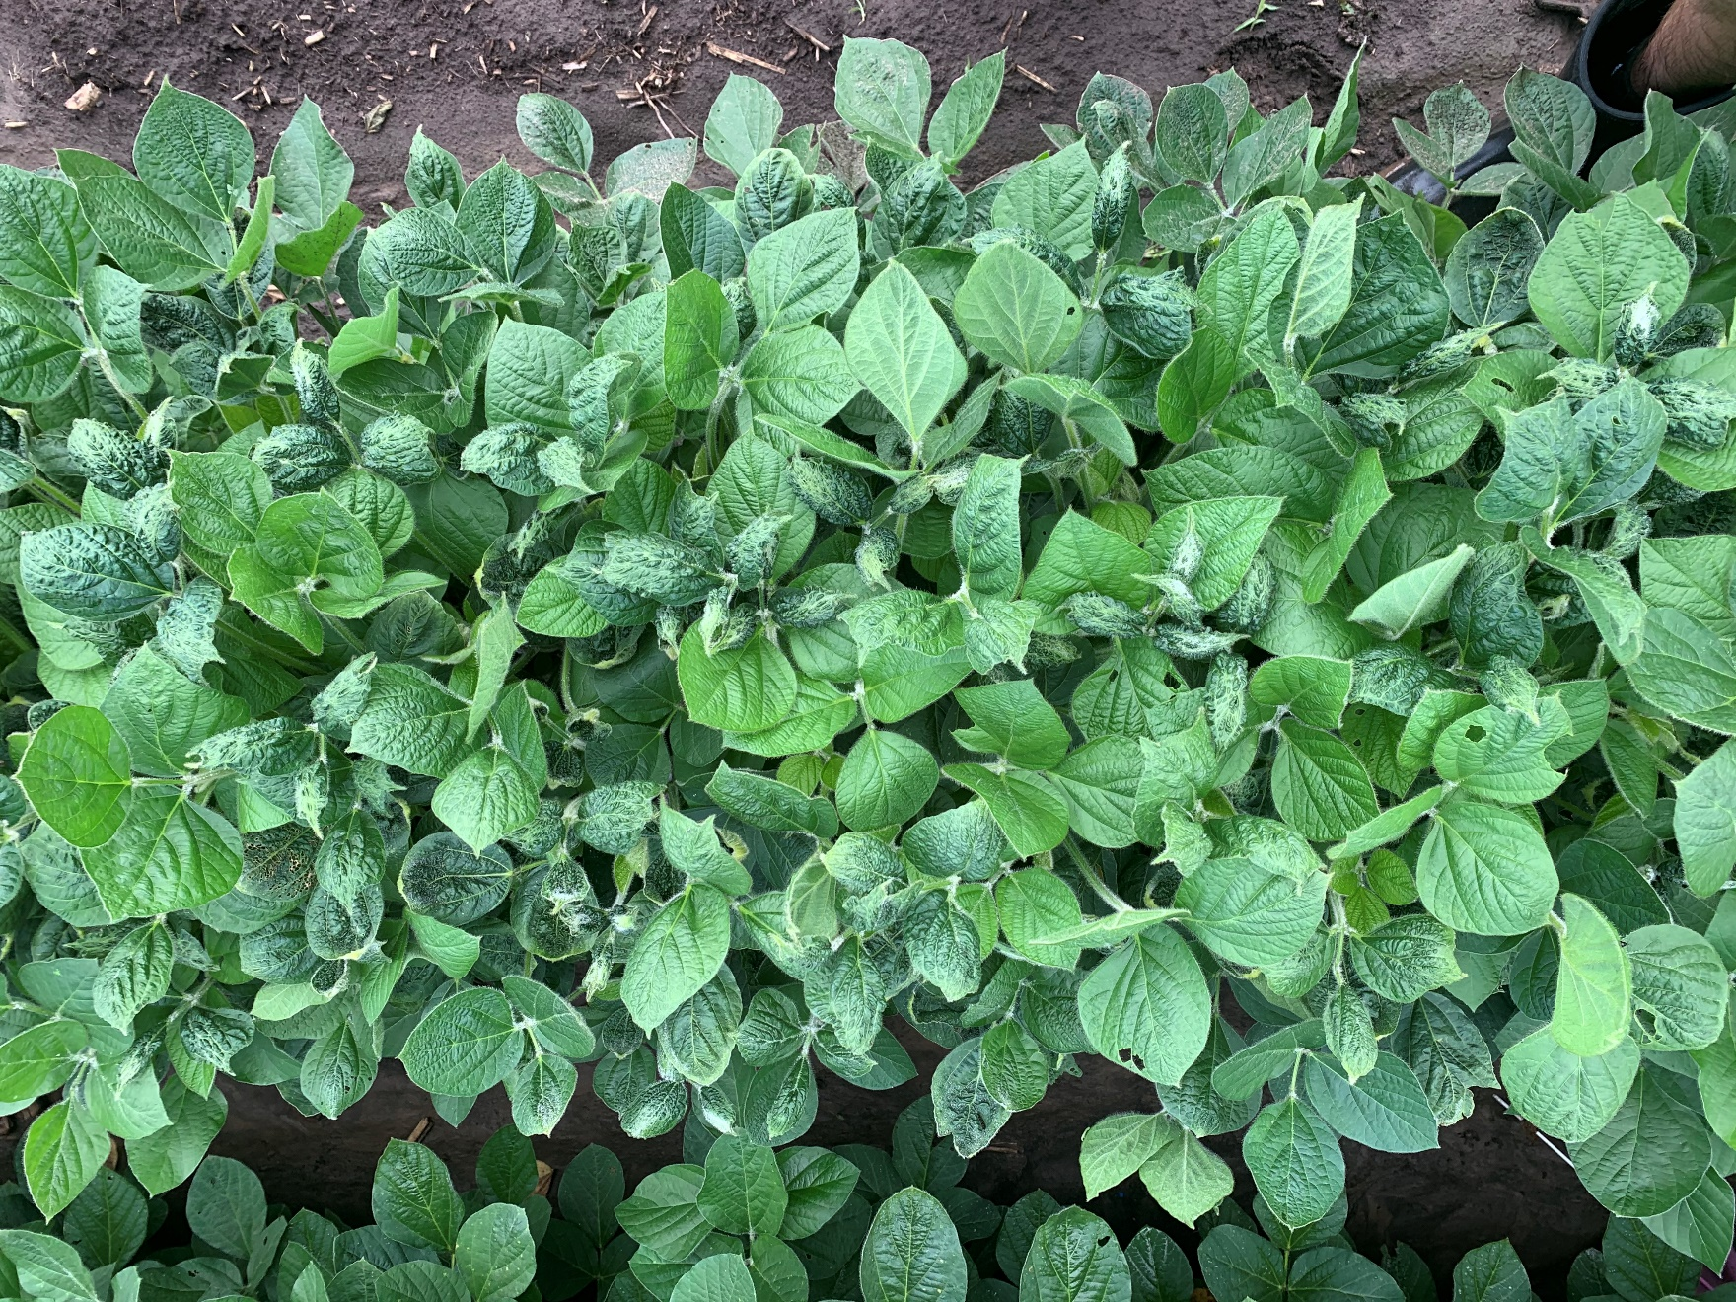

Figure 2. MON 301286 – RupXtend II VGrip + Intact at 28 DAT.

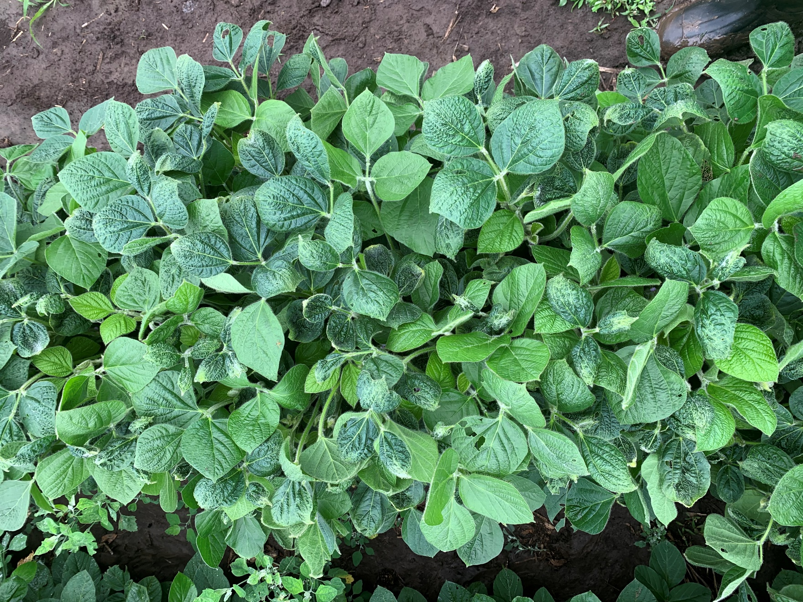

Figure 3. MON 301286 – RupXtend II VGrip + Impetro II at 28 DAT.

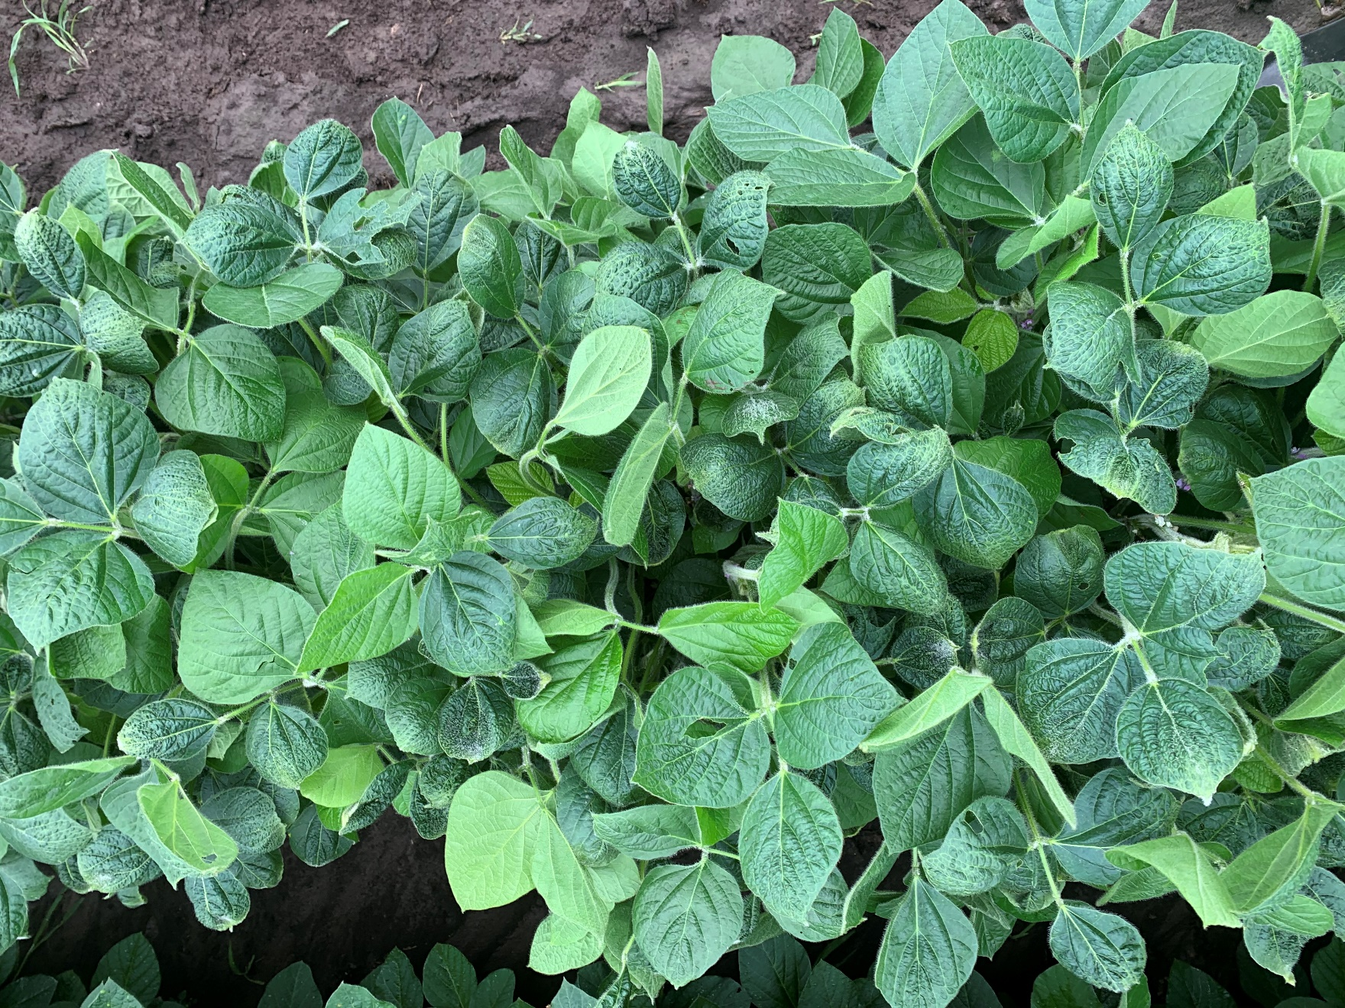

Figure 4. MON 301286 – RupXtend II VGrip + MON 51817 – VaporGrip at 28 DAT.

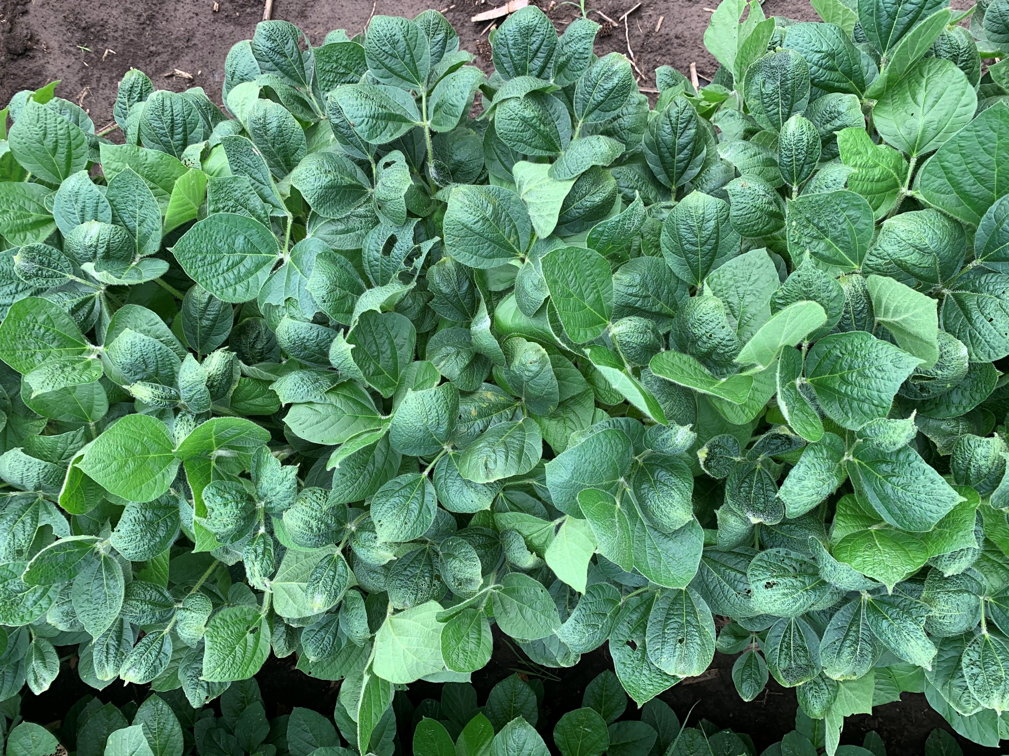

Figure 5. MON 301286 – RupXtend II VGrip + MON 51817 – VaporGrip + Intact at 28 DAT.

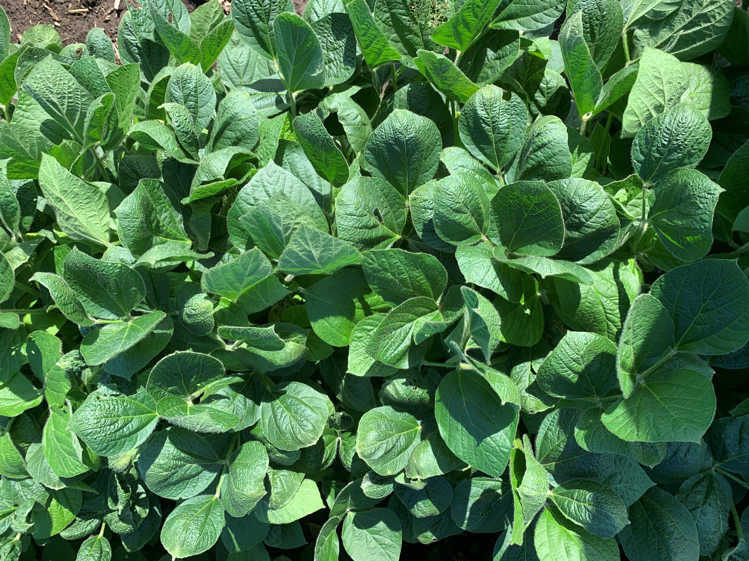

Figure 6. MON 301286 – RupXtend II VGrip + MON 51817 – VaporGrip + Impetro II at 28 DAT.

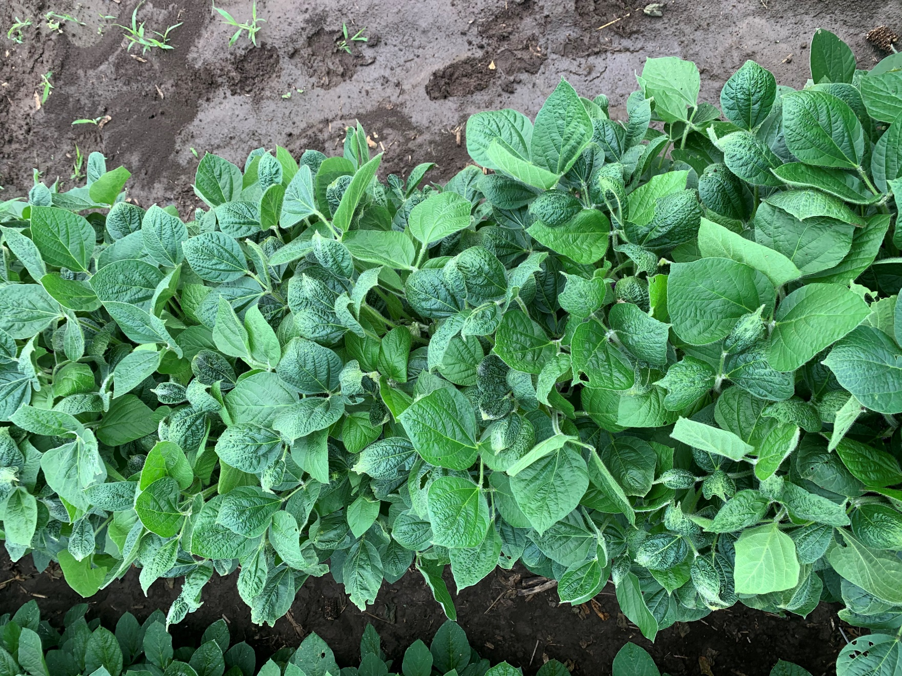

Figure 7. MON 301286 – RupXtend II VGrip + MON 301471 – VaporGrip + Guar at 28 DAT.

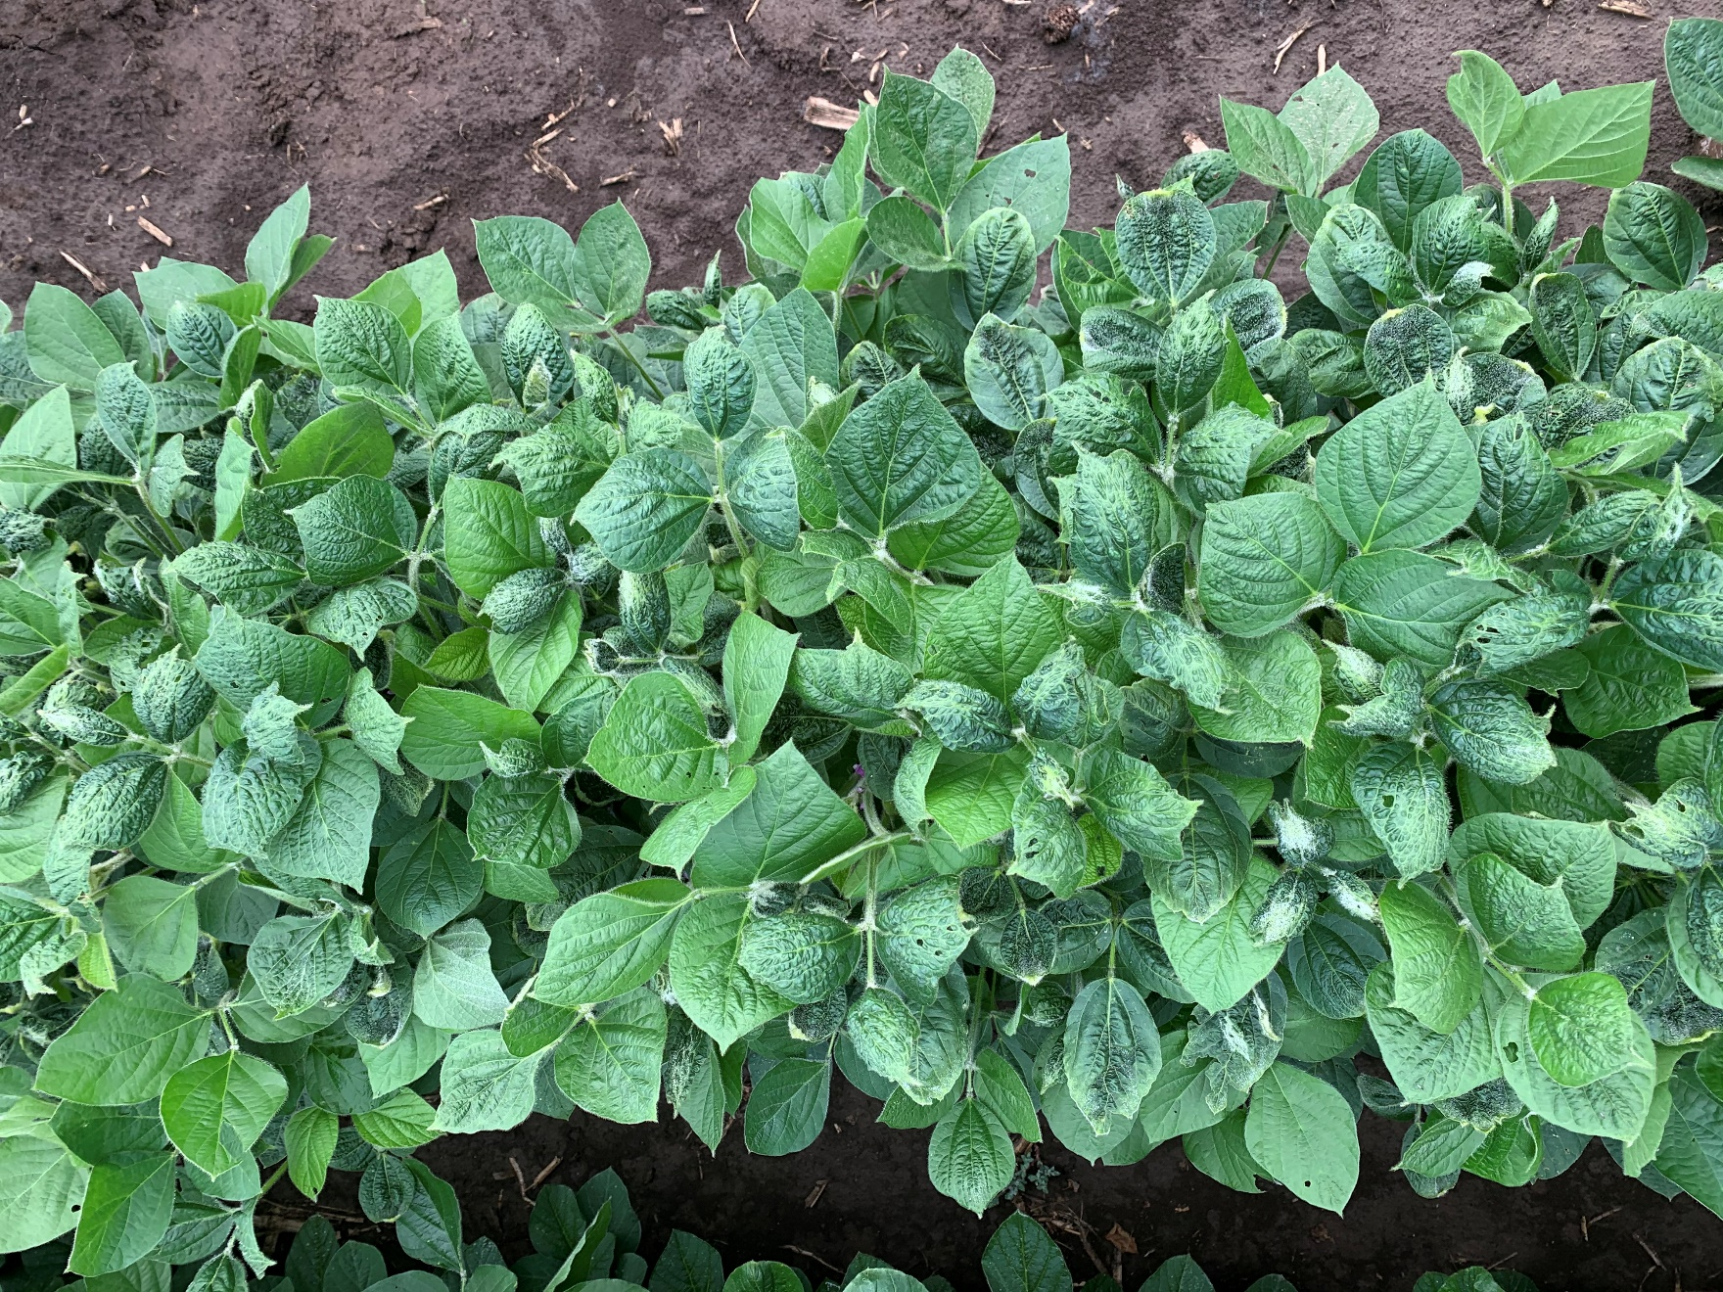

Figure 8. MON 301286 – RupXtend II VGrip + MON 301916 – VaporGrip + PCA at 28 DAT.

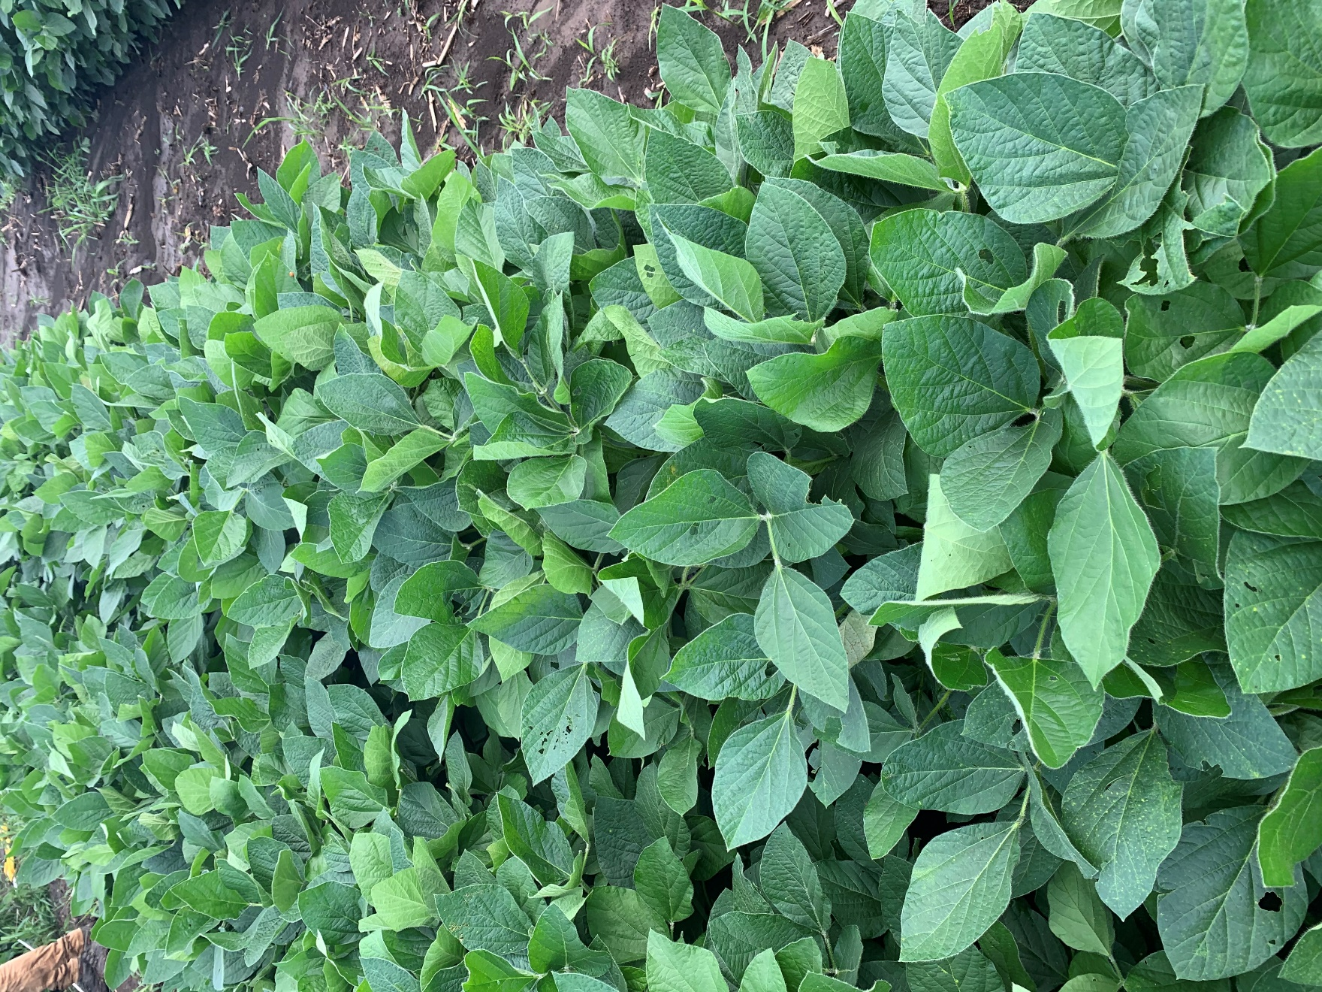

Figure 9. Nontreated Check at 28 DAT.